6. Software and Coding
6.1 Introduction to Arduino IDE
Arduino is a prototype platform (open-source) based on an easy-to-use hardware and software. It consists of a circuit board, which can be programmed (referred to as a microcontroller) and a ready-made software called Arduino IDE (Integrated Development Environment), which is used to write and upload the computer code to the physical board.
The key features are:
- Arduino boards are able to read analog or digital input signals from different sensors and turn it into an output such as activating a motor, turning LED on/off, connect to the cloud and many other actions.

- You can control your board functions by sending a set of instructions to the microcontroller on the board via Arduino IDE (referred to as uploading software).

- Unlike most previous programmable circuit boards, Arduino does not need an extra piece of hardware (called a programmer) in order to load a new code onto the board. You can simply use a USB cable.

- Additionally, the Arduino IDE uses a simplified version of C++, making it easier to learn to program.

- Finally, Arduino provides a standard form factor that breaks the functions of the micro-controller into a more accessible package.
After learning about the main parts of the Arduino UNO board, we are ready to learn howto set up the Arduino IDE. Once we learn this, we will be ready to upload our program onthe Arduino board.

6.1.1 Arduino data types:
Data types in C refers to an extensive system used for declaring variables or functions of different types. The type of a variable determines how much space it occupies in the storage and how the bit pattern stored is interpreted.
The following table provides all the data types that you will use during Arduinoprogramming.
Void:
The void keyword is used only in function declarations. It indicates that the function is expected to return no information to the function from which it was called.
Example:
Void Loop ( )
{
// rest of the code
}
Boolean:
A Boolean holds one of two values, true or false. Each Boolean variable occupies one byte of memory.
Example:
Boolean state= false ; // declaration of variable with type boolean and initialize it with false.
Boolean state = true ; // declaration of variable with type boolean and initialize it with false.
Char:A data type that takes up one byte of memory that stores a character value. Character literals are written in single quotes like this: 'A' and for multiple characters, strings use double quotes: "ABC".
However, characters are stored as numbers. You can see the specific encoding in the ASCII chart. This means that it is possible to do arithmetic operations on characters, in whichthe ASCII value of the character is used. For example, 'A' + 1 has the value 66, since theASCII value of the capital letter A is 65.
Example:
Char chr_a = ‘a’ ;//declaration of variable with type char and initialize it with character a.
Char chr_c = 97 ;//declaration of variable with type char and initialize it with character 97
Unsigned char:
Unsigned char is an unsigned data type that occupies one byte of memory. The unsigned char data type encodes numbers from 0 to 255.
Example:
Unsigned Char chr_y = 121 ; // declaration of variable with type Unsigned char and initialize it with character y
Byte:
A byte stores an 8-bit unsigned number, from 0 to 255.
Example:
byte m = 25 ;//declaration of variable with type byte and initialize it with 25
int:
Integers are the primary data-type for number storage. int stores a 16-bit (2-byte) value. This yields a range of -32,768 to 32,767 (minimum value of -2^15 and a maximum value of (2^15) - 1).
The int size varies from board to board. On the Arduino Due, for example, an int stores a 32-bit (4-byte) value. This yields a range of -2,147,483,648 to 2,147,483,647 (minimum value of -2^31 and a maximum value of (2^31) - 1).
Example:
int counter = 32 ;// declaration of variable with type int and initialize it with 32.
Unsigned int:
Unsigned ints (unsigned integers) are the same as int in the way that they store a 2 byte value. Instead of storing negative numbers, however, they only store positive values, yielding a useful range of 0 to 65,535 (2^16) - 1). The Due stores a 4 byte (32-bit) value, ranging from 0 to 4,294,967,295 (2^32 - 1).
Example:
Unsigned int counter= 60 ; // declaration of variable with type unsigned int and initialize it with 60.
Word:
On the Uno and other ATMEGA based boards, a word stores a 16-bit unsigned number. On the Due and Zero, it stores a 32-bit unsigned number.
Example
word w = 1000 ;//declaration of variable with type word and initialize it with 1000.
Long:
Long variables are extended size variables for number storage, and store 32 bits (4 bytes), from 2,147,483,648 to 2,147,483,647.
Example:
Long velocity= 102346 ;//declaration of variable with type Long and initialize it with 102346
Unsigned long:Unsigned long variables are extended size variables for number storage and store 32 bits (4 bytes). Unlike standard longs, unsigned longs will not store negative numbers, making their range from 0 to 4,294,967,295 (2^32 - 1).
Example:
Unsigned Long velocity = 101006 ;// declaration of variable with type Unsigned Long and initialize it with 101006.
Short:
A short is a 16-bit data-type. On all Arduinos (ATMega and ARM based), a short stores a 16-bit (2-byte) value. This yields a range of -32,768 to 32,767 (minimum value of -2^15 and a maximum value of (2^15) - 1).
Example:
short val= 13 ;//declaration of variable with type short and initialize it with 13
Float:
Data type for floating-point number is a number that has a decimal point. Floating-point numbers are often used to approximate the analog and continuous values because they have greater resolution than integers.
Floating-point numbers can be as large as 3.4028235E+38 and as low as 3.4028235E+38. They are stored as 32 bits (4 bytes) of information.
Example:
float num = 1.352;//declaration of variable with type float and initialize it with 1.352.
Double:
On the Uno and other ATMEGA based boards, Double precision floating-point number occupies four bytes. That is, the double implementation is exactly the same as the float, with no gain in precision. On the Arduino Due, doubles have 8-byte (64 bit) precision.
Example:
double num = 45.352 ;// declaration of variable with type double and initialize it with 45.352.
In this section, we will learn in easy steps, how to set up the Arduino IDE on our computerand prepare the board to receive the program via USB cable.
Step 1: First you must have your Arduino board (you can choose your favorite board) anda USB cable. In case you use Arduino UNO, Arduino Duemilanove, Nano, Arduino Mega2560, or Diecimila, you will need a standard USB cable (A plug to B plug), the kind youwould connect to a USB printer as shown in the following image.
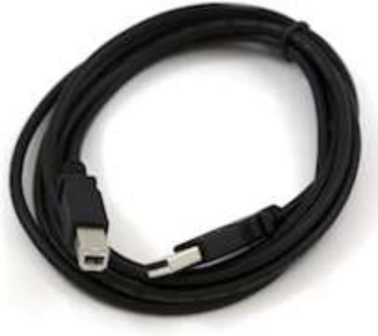
Figure 5.12: USB Cable
Step 2: Download Arduino IDE Software.
You can get different versions of Arduino IDE from the Download page on the Arduino Official website. You must select your software, which is compatible with your operating system (Windows, IOS, or Linux). After your file download is complete, unzip the file.

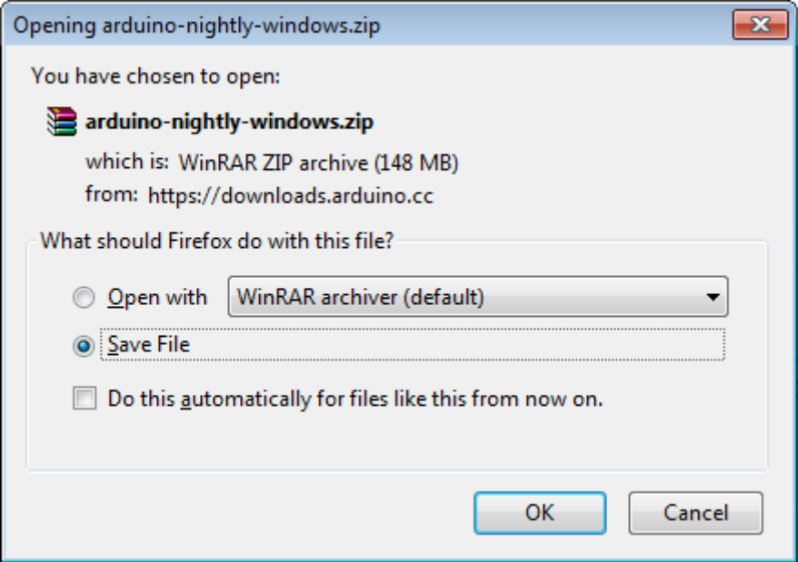

Step 3: Power up your board.
The Arduino Uno, Mega, Duemilanove and Arduino Nano automatically draw power from either, the USB connection to the computer or an external power supply. If you are using an Arduino Diecimila, you have to make sure that the board is configured to draw power from the USB connection. The power source is selected with a jumper, a small piece of plastic that fits onto two of the three pins between the USB and power jacks. Check that it is on the two pins closest to the USB port. Connect the Arduino board to your computer using the USB cable. The green power LED (labeled PWR) should glow.
Step 4: Launch Arduino IDE.
After your Arduino IDE software is downloaded, you need to unzip the folder. Inside the folder, you can find the application icon with an infinity label (application.exe). Doubleclick the icon to start the IDE.

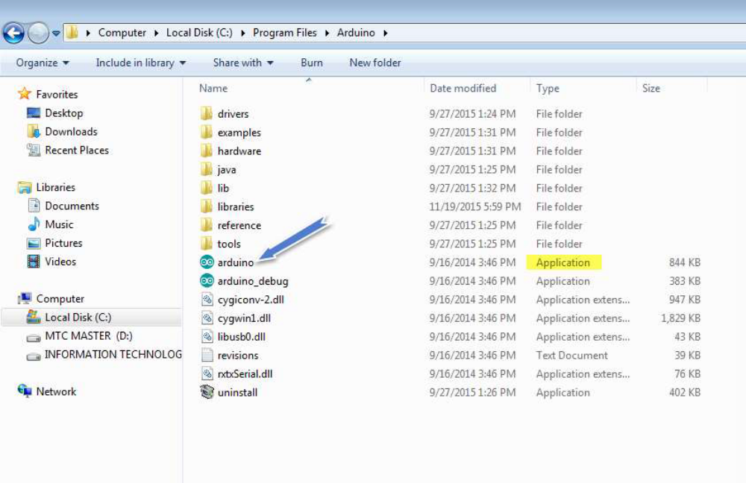
Step 5: Open your first project.
Once the software starts, you have two options:
- Create a new project.
- Open an existing project example.

To create a new project, select File --> New.To open

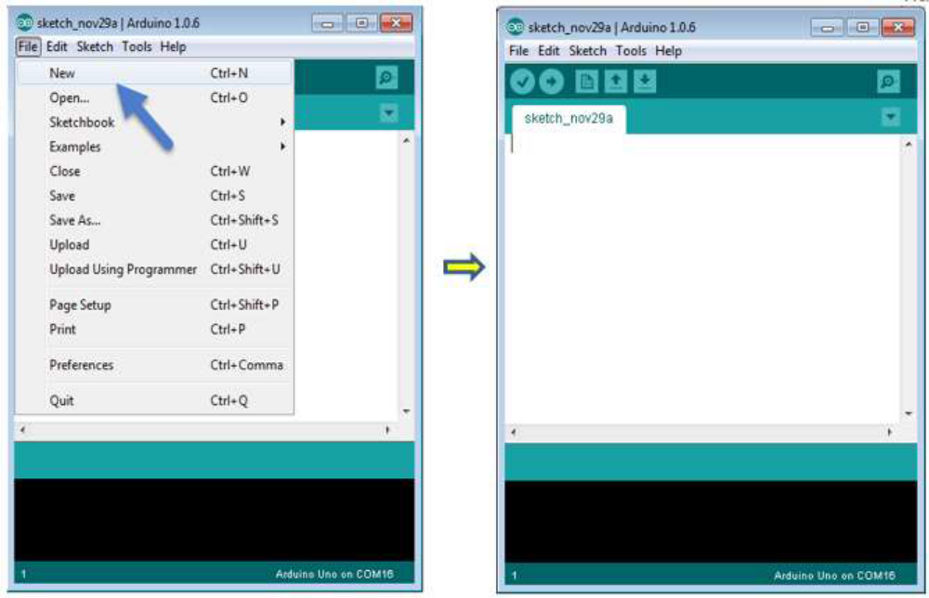
To open an existing project example, select File -> Example -> Basics -> Blink.

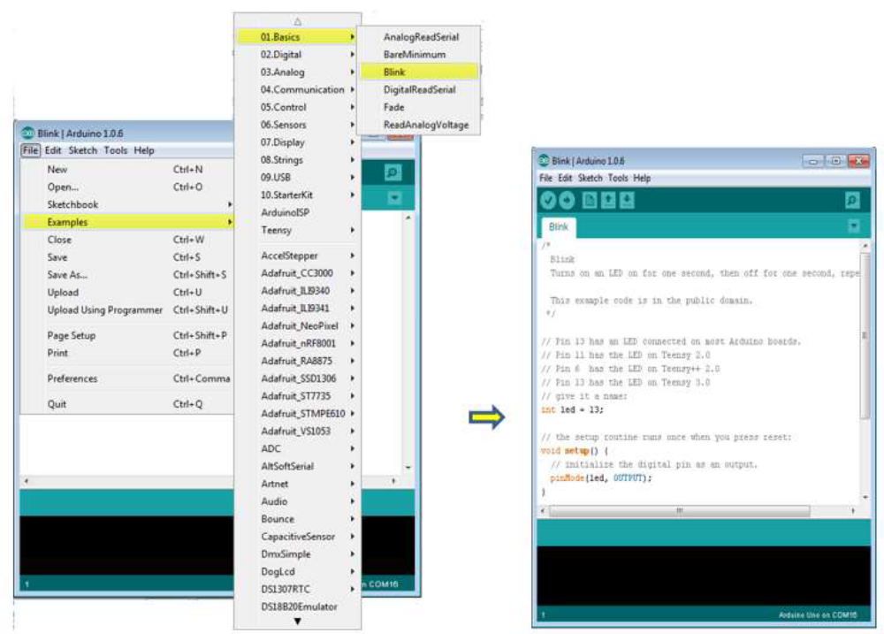
Here, we are selecting just one of the examples with the name Blink. It turns the LED on and off with some time delay. You can select any other example from the list.
Step 6: Select your Arduino board.
To avoid any error while uploading your program to the board, you must select the correct Arduino board name, which matches with the board connected to your computer.
Go to Tools -> Board and select your board

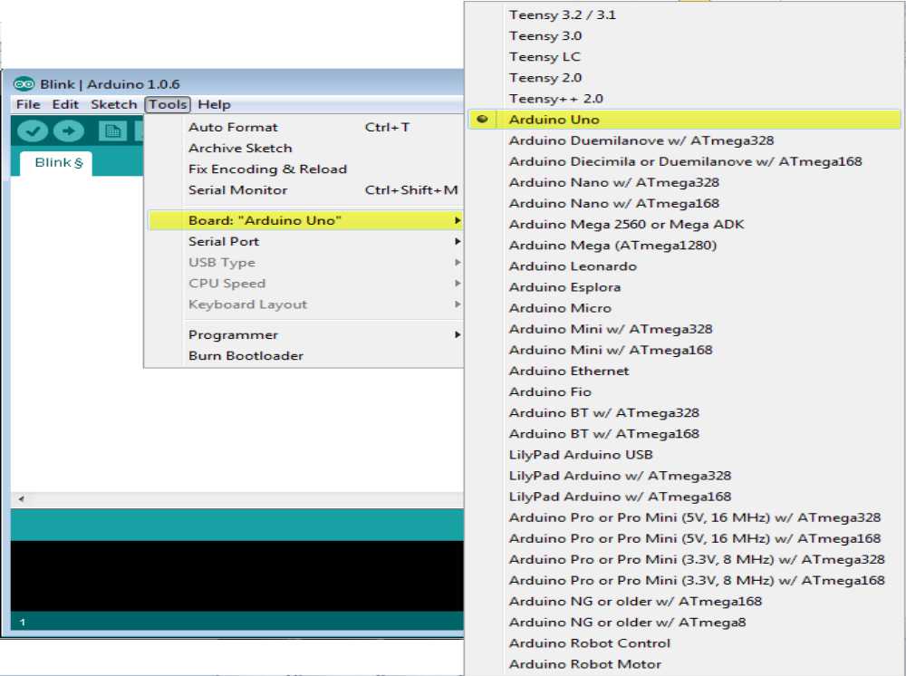

Here, we have selected Arduino Uno board according to our tutorial, but you must select the name matching the board that you are using

Step 7: Select your serial port.
Select the serial device of the Arduino board. Go to Tools ->Serial Port menu. This is likely to be COM3 or higher (COM1 and COM2 are usually reserved for hardware serial ports). To find out, you can disconnect your Arduino board and re-open the menu, the entry that disappears should be of the Arduino board. Reconnect the board and select that serial port.

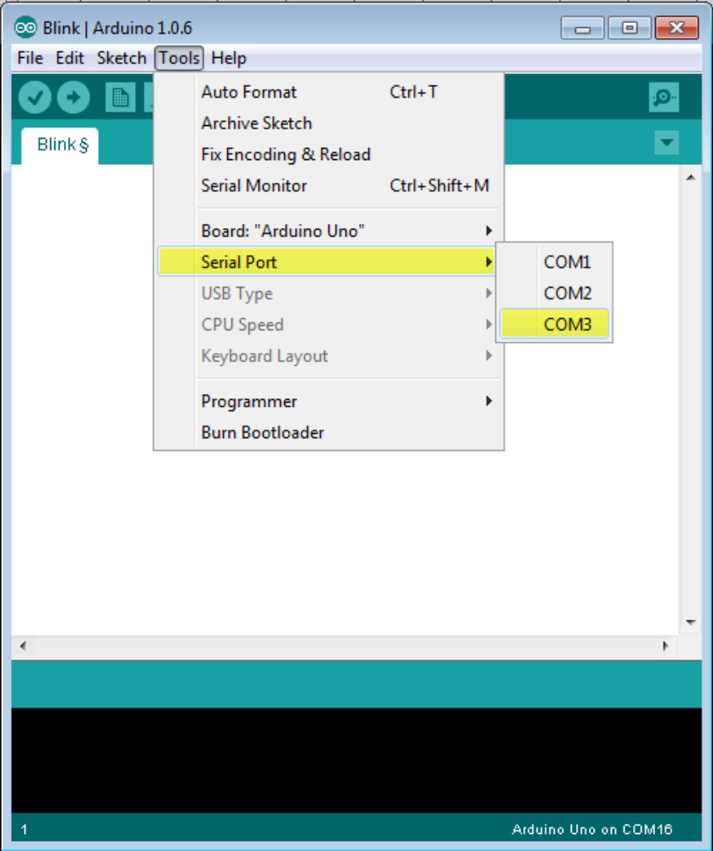
Step 8: Upload the program to your board.
Before explaining how we can upload our program to the board, we must demonstrate the function of each symbol appearing in the Arduino IDE toolbar.
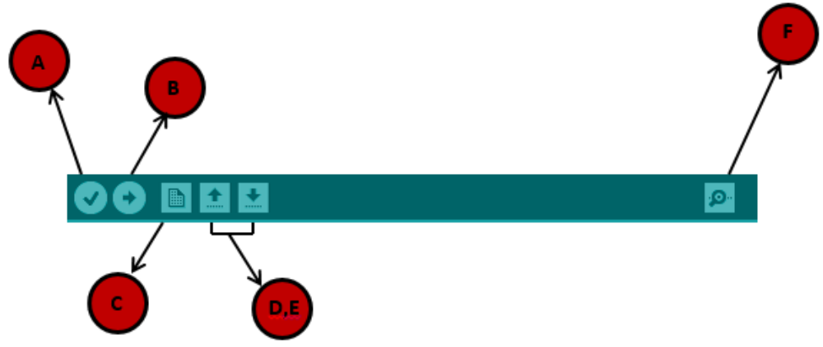
A- Used to check if there is any compilation error.
B- Used to upload a program to the Arduino board.
C- Shortcut used to create a new sketch.
D- Used to directly open one of the example sketch.
E- Used to save your sketch.
F- Serial monitor used to receive serial data from the board and send the serial data to the board.
Now, simply click the "Upload" button in the environment. Wait a few seconds; you will see the RX and TX LEDs on the board, flashing. If the upload is successful, the message "Done uploading" will appear in the status bar.
Note: If you have an Arduino Mini, NG, or other board, you need to press the reset button physically on the board, immediately before clicking the upload button on the Arduino Software.
Arduinoprogramming stracture
In this chapter, we will study in depth, the Arduino program structure and we will learn more new terminologies used in the Arduino world. The Arduino software is open-source. The source code for the Java environment is released under the GPL and the C/C++ microcontroller libraries are under the LGPL.
Sketch: The first new terminology is the Arduino program called “sketch”.
Structure
Arduino programs can be divided in three main parts: Structure, Values (variables and constants), and Functions. In this tutorial, we will learn about the Arduino software program, step by step, and how we can write the program without any syntax or compilation error.
Let us start with the Structure. Software structure consist of two main functions:
- Setup( ) function
- Loop( ) function

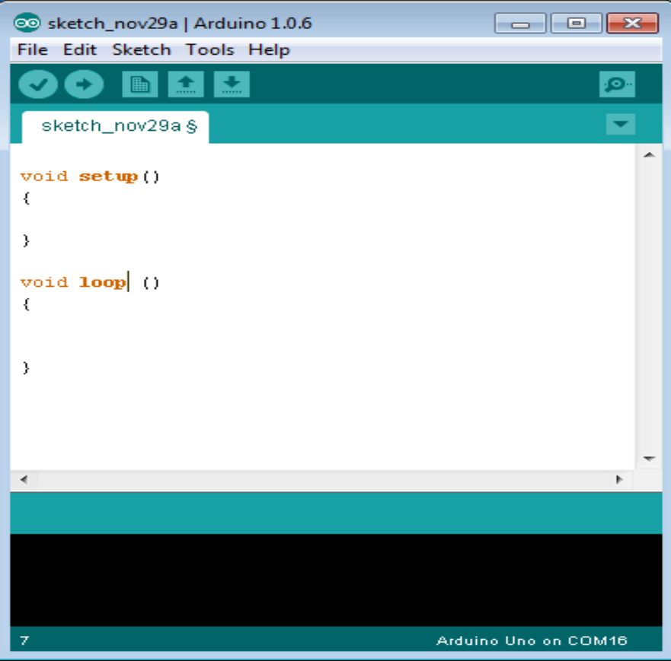

Void setup ( )
{
}

PURPOSE:
The setup() function is called when a sketch starts. Use it to initialize the variables, pin modes, start using libraries, etc. The setup function will only run once, after each power up or reset of the Arduino board.
INPUT
OUTPUT
RETURN

Void Loop ( )
{
}

PURPOSE:
After creating a setup() function, which initializes and sets the initial values, the loop() function does precisely what its name suggests, and loops secutively, allowing your program to change and respond. Use it to activelycontrol the Arduino board.
INPUT
OUTPUT
RETURN

